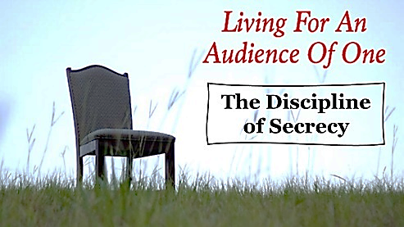
“He who dwells in the secret place of the Most High Shall abide under the shadow of the Almighty.” - Psalm 91:1 NKJV

Entering the “Yoke of Grace” – Mat. 11:28-30

Disciplines of Abstinence - To refrain voluntarily and temporarily from normal human needs to disentangle ourselves from their claims on us
- Solitude is choosing to step free from human relationships for a time, in isolation or anonymity, to make room for occupation of our lives by God.

- Silence completes solitude. It is not an absence but a presence, a positive reality, which we experience in quiet or in a place with only natural sounds

- Fasting is abstaining in some significant way from food and possibly from drink in pursuit of a higher joy, a consuming passion or in preparation for a spiritually demanding undertaking. (We may also fast from media or other things.)
- Frugality - is abstaining from using money or goods at our disposal, refusing to gratify our desires for status, glamor, or luxury.

- Sacrifice - The giving of that which I would normally use for my own needs in order to demonstrate my love for the recipient, my freedom from the need to bless myself, and to declare my trust in God to provide.

The Posture of Sacrifice - Rom 12:1
Degrees of Sacrifice - Offering that is foundational, generous, uncomfortable, painful
The Elements of Sacrifice

- Heart - Psalm 51:16-17, 1 Samuel 15:22, 1 Cor. 13:3, 2 Cor. 8:1-5
- Cost - 1 Chronicles 21:23-24
- Faith – Heb. 11:17-19, Luke 21:1-4 ESV

The Picture of Sacrifice – Phil. 2:3-1, 2 Cor. 8:9

Secrecy – to abstain from making our good ________ or ___________ known, so as to __________________ only our Father in heaven.

Signs of Approval Bondage
- we habitually _____________________ ourselves with others
- We get overly ___________________ in ordinary situations
- We have a nagging sense that we are _____________________
- We get ___________________ of others success or praise
- We find ourselves consistently trying to ____________________
- We are worried that others will think ill of us if they found out that we are an approval addict

The Discipline of Secrecy – Leads to Freedom of heart and PEACE of mind,
it is vital in stabilizing our walk with God!
“He who dwells in the secret place of the Most High Shall abide under the shadow of the Almighty.” Psalm 91:1 NKJV

“You hide them in the secret place of Your presence from the conspiracies of man; You keep them secretly in a shelter from the strife of tongues.” - Psalm 31:20 NASB
The Quest for Validation
Galatians 1:10

“In the discipline of secrecy… we abstain from causing our good deeds and qualities to be known. We may even take steps to prevent them from being known… We learn to love to be unknown and even to accept misunderstanding without the loss of our ______________, ___________, or __________________ …” – Willard

Living for an Audience of ______________________

- Jesus often avoided drawing attention to himself… Lk. 5:16, Mk. 7:24, 9:9-10

- Secrecy protects from __________________ and fosters _______________

  - In ___________________ - Matthew 6:1-4
  - In ___________________ - Matthew 6:5-9
  - In ___________________ - Matthew 6:16-18
Fruits of Secrecy
- Denying ourselves attention and praise is a powerful practice for soul transformation.

  - _________________ - acknowledges God as ___________ of all
  - _________________ - identity from being “__________________”
  - _________________ - partners in the same secret “___________”
  - _________________ - keeps the ________________, the treasure!

